MEMORIAL SERVICE
FOR
<NAME>
<POSITION>
MICHIGAN DEPARTMENT

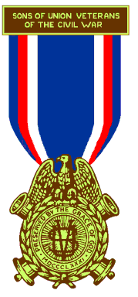

SONS OF UNION VETERANS
OF THE
CIVIL WAR
<Date>

<Location>
<Address>
<City>, Michigan

MEMORIAL SERVICE

SONS OF A UNION VETERAN OF THE CIVIL WAR

Commander — We are assembled here to pay our last tribute of respect to a Son of a Union Veteran of the Civil War, James T. Lyons. Let us, therefore, unite in prayer. The Chaplain will invoke the Divine blessing.

Chaplain — God of all nations and Father of us all, listen to our prayers, give Your beloved peace in our sorrow. You are our refuge and strength. Though the earth be removed and though the mountains be carried away. Your love abides. You are with us. Behold, You have made our days as a handbreadth and our age is as nothing before You. The life of man is swifter than the weaver’s shuttle. Like the clouds, he is consumed and vanishes away. His days are few. He goes down to the grave and does not return. Neither will he return again to us and the places that knew him shall know him no more. We thank You that You have promised that he shall live again. Accept our earnest petitions so that when taps shall sound and our earthly lights go out, we may enter the Heavenly Camp where our Fathers have gone before, carrying with us an imperishable faith in Fraternity, Charity, and Loyalty and to Thy great name shall be the praise forever and forever. Amen.

Patriotic Instructor — A noble son of a noble ancestor has fallen. His trials and toils are over and he has entered into eternal rest. As his forefather offered his life, his fortune, his sacred honor for the preservation of this Country in the hour of her greatest need, so our Brother pledged himself to the protection of the Flag of his Country and the guarantee of equal rights to all under that Flag. May our hearts here be inspired anew with the spirit of patriotism.

Junior Vice Commander — We have here assembled in the capacity of Sons of Union Veterans of the Civil War to pay the last tribute of respect to the memory of our departed Brother. While we mourn his loss and shall miss him from our Camp meetings, we rejoice that where he is now there is no more parting, no sorrow, no tears. Fraternity bound us by such strong ties here, we shall be true to his memory, and be reunited in the world that is to come.

Senior Vice Commander — We have here before us all that is mortal of a Brother who was pledged to exercise the greatest of Christian virtues, that of Charity. If our Brother had any weakness of human nature, such as are common to all, let us bury them with him and may his virtues be to us as a guiding star through the remainder of our lives.

Chaplain — Brothers, some scriptures. “Yea, though I walk through the valley of the shadow of death, I will fear no evil; for Thou art with me. Thy rod and Thy staff they comfort me.”

“God is our refuge and strength, a very present help in trouble.”

“And call upon me in the day of trouble: I will deliver Thee, and Thou shalt glorify me.”
Blessed are they that mourn; for they shall be comforted.”
“Then shall the King say unto them on his right hand. Come, ye blessed of my Father, inherit the kingdom prepared for you from the foundation of the world.”

“Brother, we lay thee down to rest. We honor your memory and commit your soul in tenderness and mercy to our Infinite God.”

“May the blessing of God Almighty Father, Son and Holy Ghost and the grace of our Lord and Savior, Jesus Christ, rest upon and abide with us forever, Amen.”

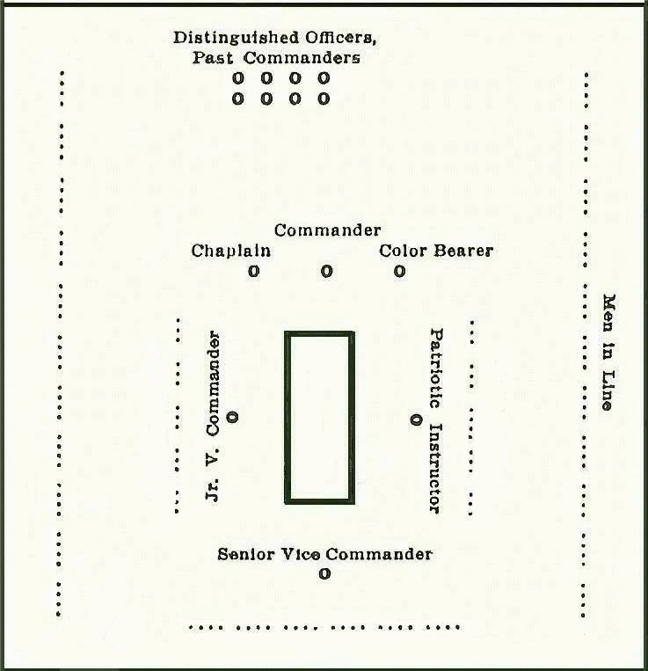
SONS OF UNION VETERANS OF THE CIVIL WAR
Department of Michigan
Lansing/Sunfield Curtenius Guard Camp #17
Death Notice

NAME:

HOME ADDRESS:

CITY, STATE, ZIP:

DATE of: Birth -
Death -

PLACE of: Birth -
Death -
Burial -

CAMP AFFILIATION:

CAMP OFFICES HELD: :
DEPARTMENT OFFICES HELD: .
NATIONAL OFFICES HELD: .

CIVIL WAR ANCESTOR NAME:
RANK & UNIT:
RELATIONSHIP:

OTHER MEMBERSHIPS, ACCOMPLISHMENTS, etc.:

CAMP INFORMANT: Keith

OBITUARY
<Name of Newspaper>
<(Death Date)>

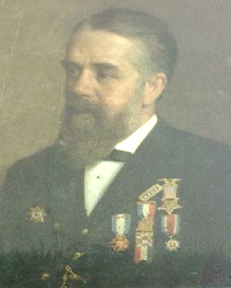

<Photograph of Member> <Picture of badge of highest office held>
<Name>
<Birth Year – Death Year>

CURTENIUS GUARD CAMP #17, Sunfield, Michigan

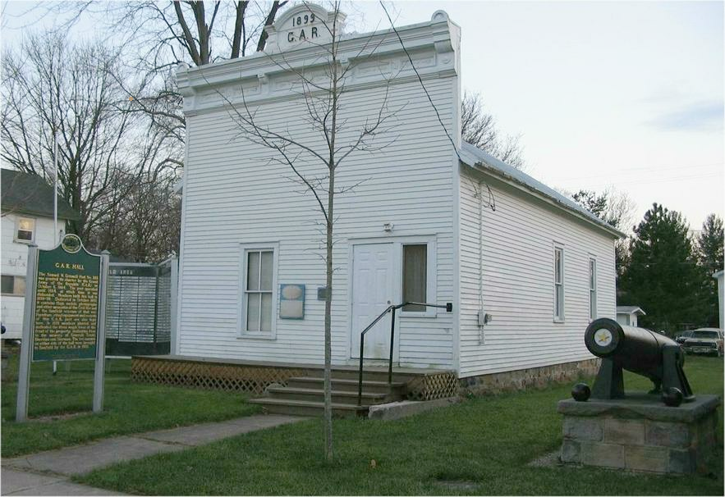

Early in 1983, Keith Harrison and four others met in the basement of his then Okemos home to form a Camp of the Sons of Union Veterans of the Civil War (SUVCW). From this humble beginning, Curtenius Guard Camp 17 has developed into one of the most influential Camps, at both the Department and National levels, in the recent history of the Order. A Provisional Charter was granted in May of 1983. Listed on that Charter were Robert E. Evans, Thomas I. Hansen, Keith G. Harrison, Michael Mitchell, and the Rev. William C. Newmarch.

The Camp was named after the Curtenius Guard Militia Company of Mason, Michigan, mustered as Company B of the 7th Michigan Volunteer Infantry at the beginning of the Civil War. The Camp number was originally designated as Camp 7 but was subsequently and very arbitrarily changed to 17 after it was found that another Camp in Michigan already had that number.

Shortly after the Camp’s formation, hearing of the existence of a Grand Army of the Republic (GAR) Hall in Sunfield, Michigan, Keith Harrison visited the Samuel W. Grinnell GAR Post 283. Upon entering the Hall with all the memorabilia present, he noticed that one of the Allied Orders of the GAR charters on the wall was that of the Samuel W. Grinnell Camp #17, Sons of Veterans. The Camp existed and met at this Hall from 1918 to 1935. It was at that point, Brother Harrison knew that Camp 17, SUVCW had found its home. Within two months after that visit, a new Camp 17 (Curtenius Guard Camp #17) was again holding its meetings in the Hall. The Hall, in continuous use by the GAR and its Allied Orders since completion in 1899, became a focal point for Camp efforts. Extensive renovation and preservation work has been done to the structure. A state Historical Marker was dedicated on Memorial Day (May 30th) in 1987. The Hall was placed on the National Register of Historic Places in February 1992.

Recruiting efforts brought in enough members to secure a “full” Charter by April of 1985. Those appearing on the Aug. 15, 1985 Charter were Albert E. Baerren, John J. Collins, Gary J. Durken, Richard J. Estep, Robert E. Evans, Don W. Everett, Thomas I. Hansen, Kenneth W. Harris, Keith G. Harrison, Arthur T. Kelsey, John W. Knecht III, James Leighty, James T. Lyons, Bob McBrien, Michael D. Mitchell, Richard L. Moore, Mike Neuman, Father William C. Newmarch, Russel Nye, and J. Douglas Park.

The strength of the Department at that time was 55 members and with the addition of Camp 17, the membership total increased correspondingly and there were now six Camps. Unfortunately, three of the Camps were inactive and had not met for some time. The Curtenius Guard had an immediate impact on the situation and through vigorous recruiting activity, the Camp grew rapidly. It quickly became a Department “holding” Camp and as enough members from a certain area were added, efforts to organize a Camp in that area started. A “flying “squad, in various combinations, comprised of Keith Harrison, Jim Lyons, Doug Park, Richard Williams and Gary Gibson (of Camp 20) conducted organizing meetings far and wide. The result was seven new Camps and the reactivation of one of the dormant Camps with a base of members being transferred to the new units. The organization of two other new Camps and one other reactivation resulted when people in those communities expressed interest in the Order. The Department Membership-at-large Camp was instituted.

After having served as Senior Vice Department Commander for two years, Keith Harrison was elected Department Commander in 1985 and served in that capacity for three years. James T. Lyons succeeded him in this position in 1988 and 1989. Other Camp members who served in this key office included James B. Pahl, 1992, J. Douglas Park 1993, and Paul D. Hodges in 1997. Brother Hodges’ grandfather, Herrick Hodges was the first Commander of the Department of Michigan. The office of Department Secretary (and Treasurer for a good part of the time) has been held by a member of this Camp since Brother J. Douglas Park was elected to that position in 1985. He served until Richard Williams was elected in 1991. Richard Lee, who holds a dual membership (originally Camp 17, and Camp 120) was elected to the office in 1995 and continues in that position presently. Brother Williams returned to the post of Treasurer in 2002. During the Michigan Sesquicentennial (1986-87), Brothers Harrison and Lyons represented the Order on the Military Affairs Sub-Committee of the Historic Observances Committee. It was during this service that Brother Lyons reactivated the Graves Registration Program in the Department. This program was adopted as an Official Sesquicentennial Project.

During this time period, the Department of Michigan has hosted three National Encampments. Brother Lyons served as General Chairman of the Host Committee for 1988 and 1994. Doug Park stepped in for the final two months prior to the 1994 Encampment and handled the day-to-day operations. Brother Richard Williams served as General Chairman for the 2000 National Encampment. All three Encampments were held in Lansing.

Recognition has come to a number of members over the years. The Department of Michigan Abraham Lincoln Certificate of Appreciation has been awarded to Michael Mitchell (1987), Keith Harrison and James T. Lyons (1989), Paul D. Hodges (1992), J. Douglas Park and Richard Williams (1995) and James B. Pahl (1999). Former members of the Camp so recognized include Smead Edwards and William Peebles (1987) and Jerry D. Roe (1992).

Service to the National Organization involved many of the same individuals. Brother Lyons was elected and served as National Secretary from 1989-1994. He also served as Chairman of the National Encampment Site Selection Committee for five years. During that time so many Brothers from Michigan were called to serve that Past Commander-in-Chief (PCinC) Richard Schlenker dubbed the group “the Michigan Mafia”. Keith Harrison was elected Junior Vice-Commander-in-Chief in 1992 and served as Commander-in-Chief for the term 1994/1995. He was only the fourth Michiganian in the then 113-year history of the Order and the first in 46 years to serve in the Order's highest office. He had served in a variety of positions including National Patriotic Instructor, History Book Coordinator, National Membership-at-Large Coordinator and most recently for several years as the National Signals Officer and Webmaster for the National Organization. During this time, he greatly expanded the offering on the National web site, adding many innovative features and updates.

J. Douglas Park served as an elected Member of the National Council of Administration, 1995 - 1998. He had formerly served as National Membership-at-Large Coordinator and computerized those records. He has served a variety of committee assignments including the National Program and Policy Committee. Brother Richard Williams was asked to serve as National Membership List Coordinator in 1992 and served in that position until 2001. He almost single-handedly “computerized” the operation of the National Organization. He helped establish many programs to handle a variety of functions. He became the primary resource and training person in this area of activity. He continues to coach and assist in practically every area of computer operations at the National level of the Order. Brother James B. Pahl was elected National Treasurer in 1997 and served until 2001. He has served as the National Counselor, as Chairman of the National Legal Staff and Chairman of the Committee on Constitution and Regulations for several years. He was subsequently elected as Junior Vice Commandery-in-Chief (2004/05), Senior Vice Commander-in-Chief (2005/06) and Commander-in-Chief 2006/07). He was the second member of the Camp and sixth person from Michigan to attain the rank of Commander-in-Chief. Brother James T. Lyons was appointed the first Executive Director of the National Organization at the 2000 National Encampment.

Recognition has followed these activities. At the National Encampment of 1994, Brother Park was the first recipient of the Cornelius Whitehouse Award as the Outstanding Brother of the Year. Brother Richard Williams was recognized with the same Award in 2000. Keith Harrison and James B. Pahl were recognized jointly in 2001. The National Meritorious Service Award with Gold Star was presented to James T. Lyons at the 1997 National Encampment. Brothers Williams and Harrison were also later recipients of this award.

The Curtenius Guard Camp 17, Department of Michigan, was recognized as the Outstanding Camp of the Year at the 2000 National Encampment.

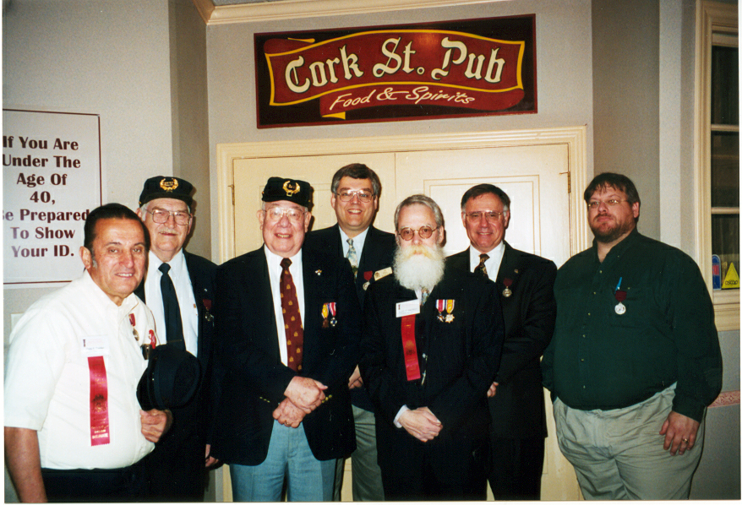
<Picture of Camp Member>

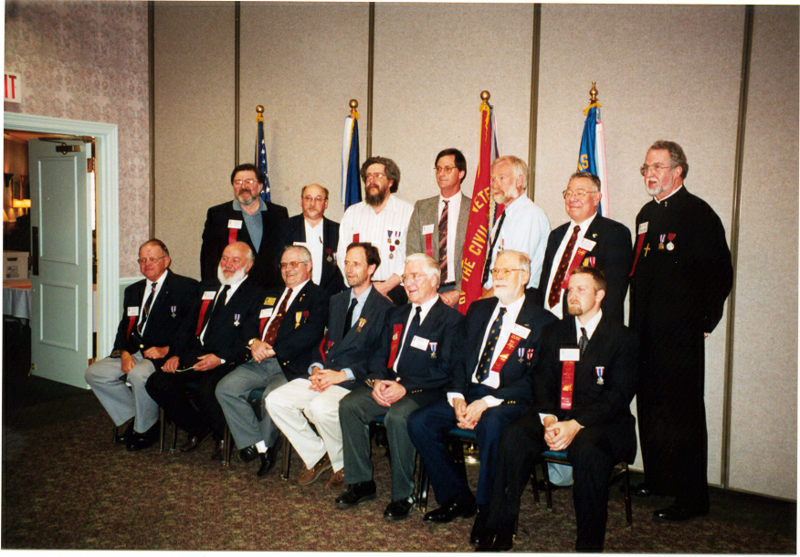
<Picture of Camp Member>

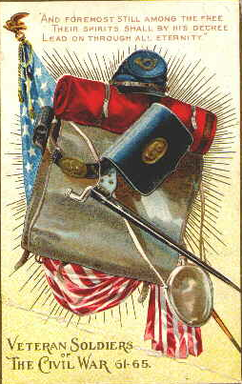

Lest we Forget

